**OBJECT ORIENTED PROGRAMMING USING C++**

**PRACTICAL FILE**



**Subject Code –** LPCIT-102

**SUBMITTED TO: SUBMITTED BY:**

**Ms.**Harjot Kaur Gill  **Name :** Harmanpreet kaur

**Branch :** IT

**Section :** A2

**U.R.N :2004921**

**C.R.N :** 2021042

**GURU NANAK DEV ENGINEERING COLLEGE**

Ludhiana ,141014

**INDEX**

|  |  |  |  |  |
| --- | --- | --- | --- | --- |
| **Sr.No.** | **Name of the Experiment** | **Page No.** | **Date** | **Remarks** |
| **1.** | To display your name using c++. |  |  |  |
| **2.** | To demonstrate the size of datatypes using c++. |  |  |  |
| **3.** | To print the values of datatypes using c++. |  |  |  |
|  |  |  |  |  |
|  |  |  |  |  |
|  |  |  |  |  |
|  |  |  |  |  |
|  |  |  |  |  |
|  |  |  |  |  |
|  |  |  |  |  |

**PRACTICAL -1**

**AIM :** **To display your name using c++.**

**CODE :**

#include<iostream>

using namespace std;

int main()

{

cout<<"Guru Nanak Dev Engineering College"<<endl;

cout<<"Name-Harmanpreet kaur"<<endl;

cout<<"Branch-IT"<<endl;

cout<<"Section-A2"<<endl;

cout<<"Roll no.: 2021042/2004921"<<endl;

return 0;

}

**OUTPUT :**

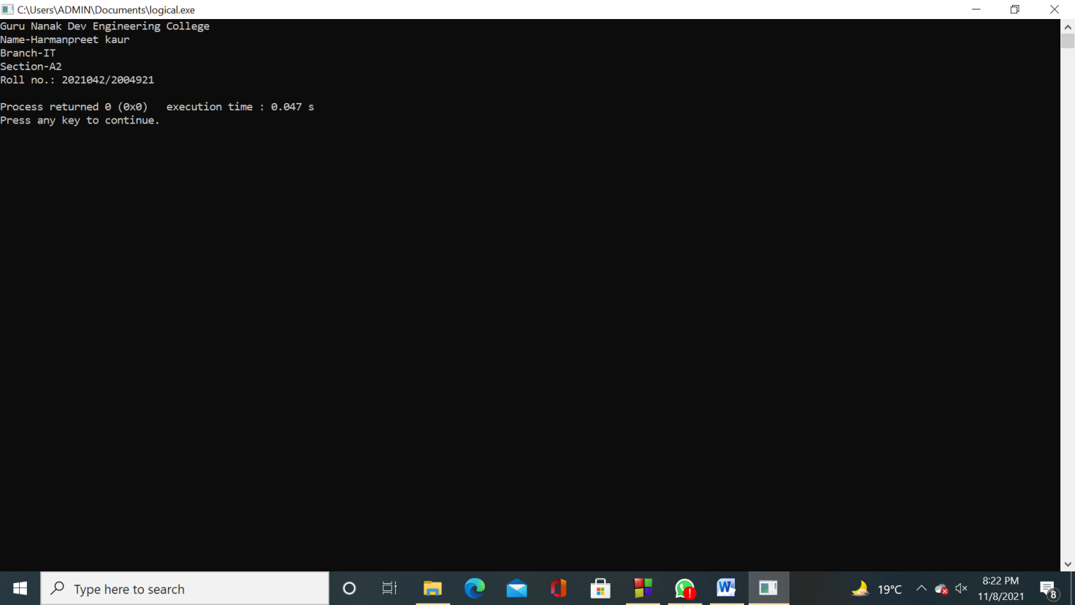

**PRACTICAL – 2**

**AIM : To demonstrate the size of datatypes using c++.**

**CODE :**

#include<iostream>

using namespace std;

int main()

{

cout<<"Name-Harmanpreet Kaur \nSection-ITa2 \nC.R.N.-2021042 \nU.R.N.-2004921 \n";

cout << "\nSize of char: " << sizeof(char) << " byte" << endl;

cout << "Size of int: " << sizeof(int) << " bytes" << endl;

cout << "Size of float: " << sizeof(float) << " bytes" << endl;

cout << "Size of double: " << sizeof(double) << " bytes" << endl;

return 0;

}

**OUTPUT :**

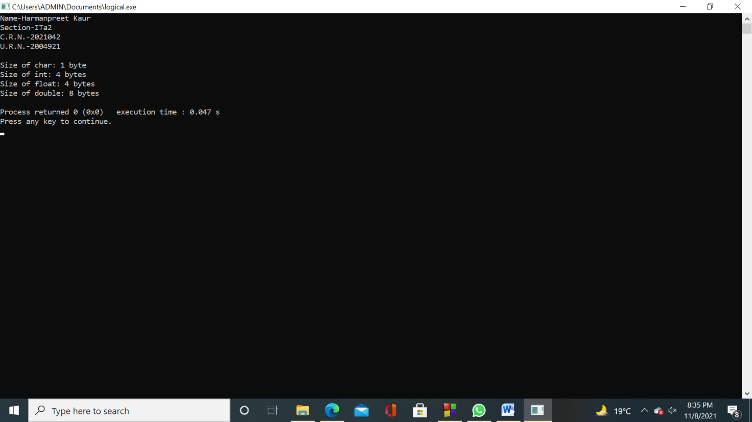

**PRACTICAL -3**

**AIM : To print the values of datatypes using c++.**

**CODE :**

#include<iostream>

using namespace std;

int main()

{

char a='D';

int b=45;

float c=65.321;

double d=54.6451;

bool e=false;

cout<<"Name-Harmanpreet Kaur \nSection-ITA2 \nC.R.N.- 2021042 \nU.R.N.-2004921 \n";

cout<<"\nThe value of char is :"<<a;

cout<<"\nThe value of int is :"<<b;

cout<<"\nThe value of float is :"<<c;

cout<<"\nThe value of double is :"<<d;

cout<<"\nThe value of boolean is :"<<e;

return 0;

}

**OUTPUT :**

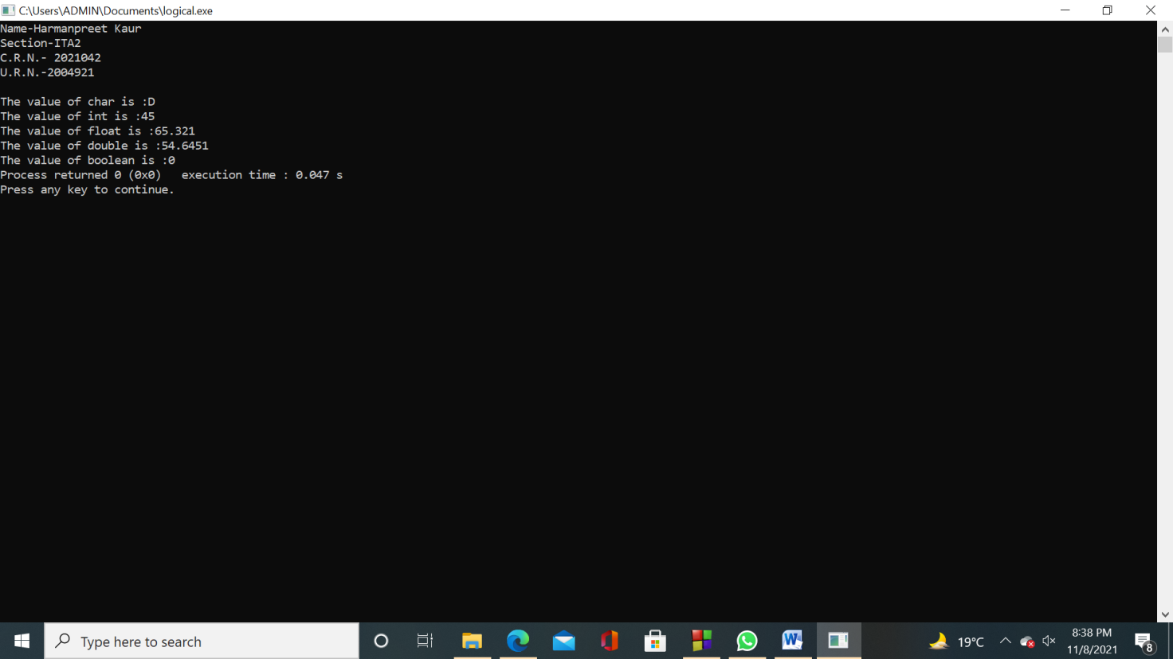

**Practical -4**

# Aim:(i )program to use the arithmetic operators .(binary)

Code:

**#include <iostream>**

**using namespace std;**

**int main() {**

**int a, b;**

**a = 7;**

**b = 2;**

**// printing the sum of a and b**

**cout << "a + b = " << (a + b) << endl;**

**// printing the difference of a and b**

**cout << "a - b = " << (a - b) << endl;**

**// printing the product of a and b**

**cout << "a * b = " << (a * b) << endl;**

**// printing the division of a by b**

**cout << "a / b = " << (a / b) << endl;**

**// printing the modulo of a by b**

**cout << "a % b = " << (a % b) << endl;**

**return 0;**

**}**

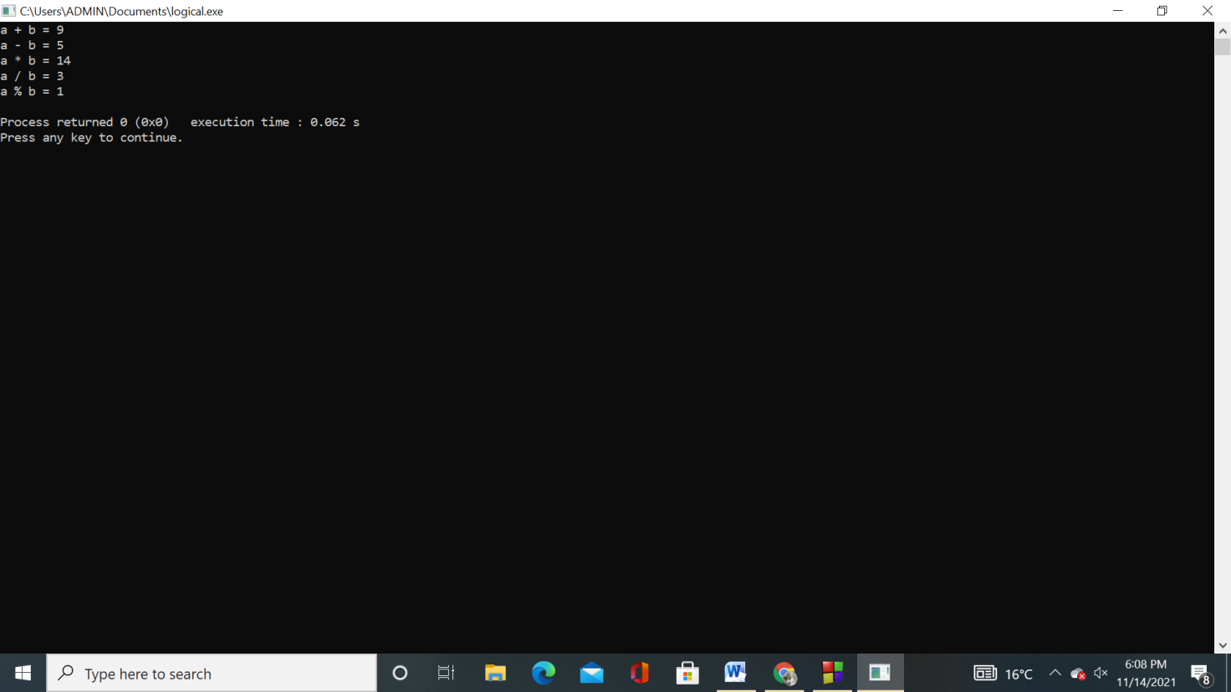

**(ii). program to use the arithmetic oprators(uniry)**

**Code:**

**#include <iostream>**

**using namespace std;**

**int main() {**

**int a = 10, b = 100, result_a, result_b;**

**// incrementing a by 1 and storing the result in result_a**

**result_a = ++a;**

**cout << "result_a = " << result_a << endl;**

**// decrementing b by 1 and storing the result in result_b**

**result_b = --b;**

**cout << "result_b = " << result_b << endl;**

**return 0;**

**}**

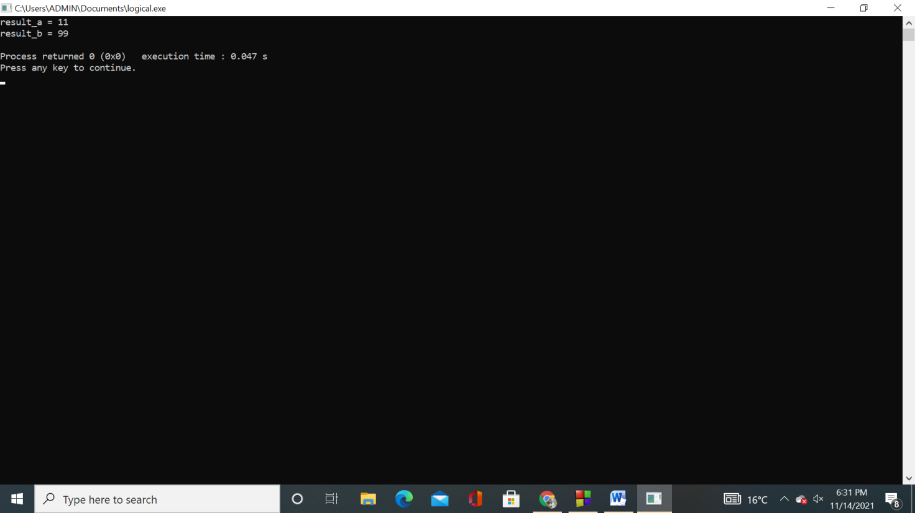

**B. Aim: program to use the assignment operator.**

**Code:**

**#include <iostream>**

**using namespace std;**

**int main() {**

**int a, b;**

**a = 2;**

**b = 7;**

**cout << "a = " << a << endl;**

**cout << "b = " << b << endl;**

**cout << "\nAfter a += b;" << endl;**

**// assigning the sum of a and b to a**

**a += b; // a = a +b**

**cout << "a = " << a << endl;**

**return 0;**

**}**

**Output:**

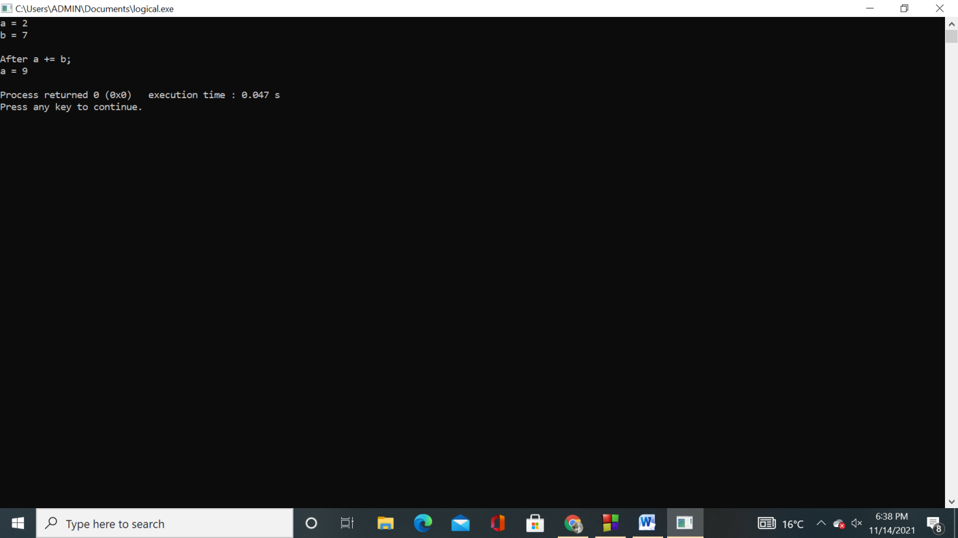

**C.program to use the relational operator**

**Code:**

**#include <iostream>**

**using namespace std;**

**int main() {**

**int a, b;**

**a = 3;**

**b = 5;**

**bool result;**

**result = (a == b); // false**

**cout << "3 == 5 is " << result << endl;**

**result = (a != b); // true**

**cout << "3 != 5 is " << result << endl;**

**result = a > b; // false**

**cout << "3 > 5 is " << result << endl;**

**result = a < b; // true**

**cout << "3 < 5 is " << result << endl;**

**result = a >= b; // false**

**cout << "3 >= 5 is " << result << endl;**

**result = a <= b; // true**

**cout << "3 <= 5 is " << result << endl;**

**return 0;**

**}**

**Output:**

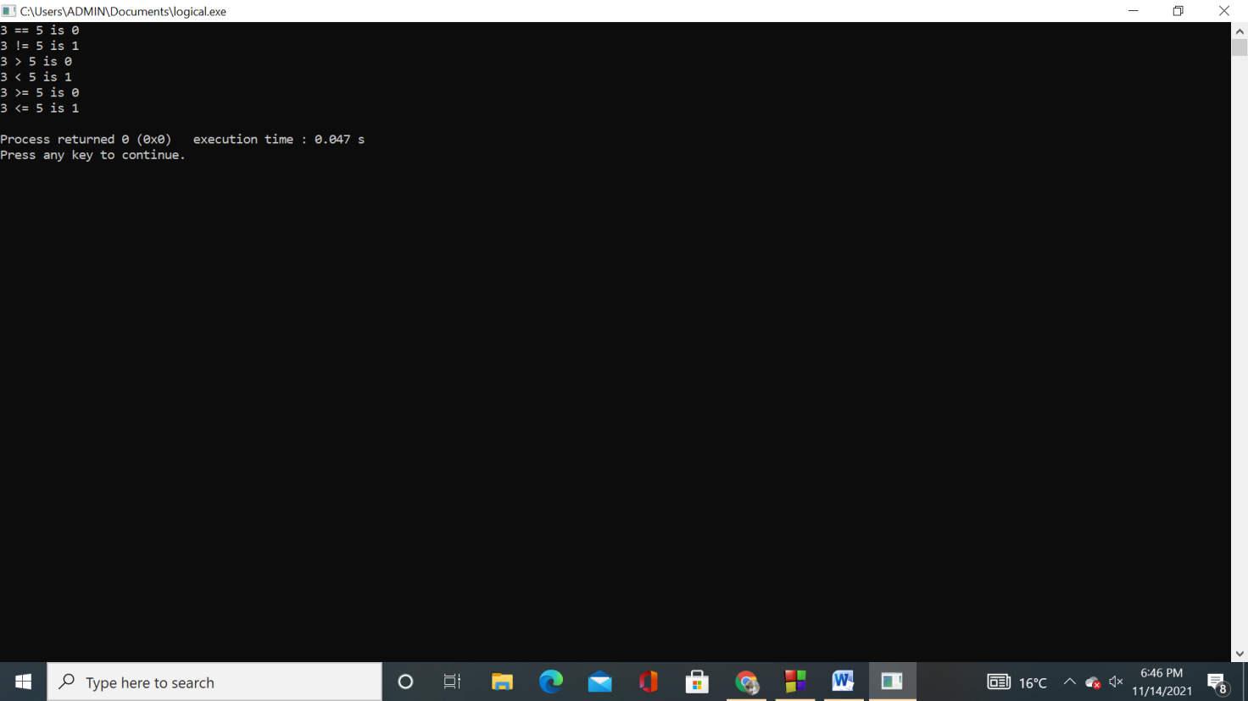

**D.program to use the logical operators**

**Code:**

**#include <iostream>**

**using namespace std;**

**int main() {**

**bool result;**

**result = (3 != 5) && (3 < 5); // true**

**cout << "(3 != 5) && (3 < 5) is " << result << endl;**

**result = (3 == 5) && (3 < 5); // false**

**cout << "(3 == 5) && (3 < 5) is " << result << endl;**

**result = (3 == 5) && (3 > 5); // false**

**cout << "(3 == 5) && (3 > 5) is " << result << endl;**

**result = (3 != 5) || (3 < 5); // true**

**cout << "(3 != 5) || (3 < 5) is " << result << endl;**

**result = (3 != 5) || (3 > 5); // true**

**cout << "(3 != 5) || (3 > 5) is " << result << endl;**

**result = (3 == 5) || (3 > 5); // false**

**cout << "(3 == 5) || (3 > 5) is " << result << endl;**

**result = !(5 == 2); // true**

**cout << "!(5 == 2) is " << result << endl;**

**result = !(5 == 5); // false**

**cout << "!(5 == 5) is " << result << endl;**

**return 0;**

**}**

**Output:**

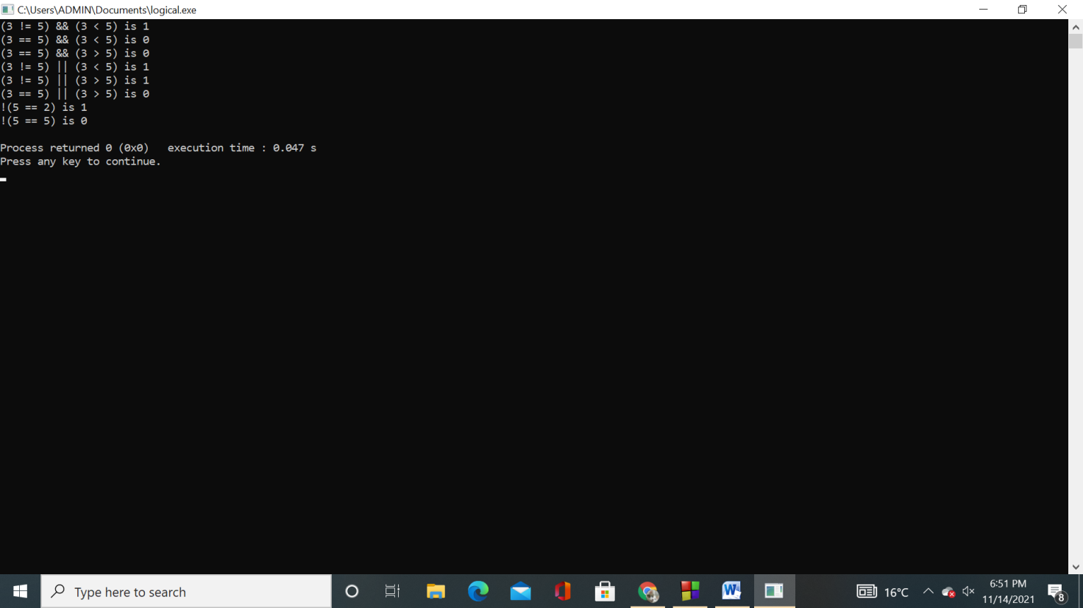

**E.program to use bitwise operator**

**Code:**

**#include <iostream>**

**using namespace std;**

**int main() {**

**int a = 7; // a = 111**

**int b = 5; // b = 101**

**cout << "Bitwise Operators\n";**

**cout << "a & b = " << (a&b) << "\n";**

**cout << "a | b = " << (a|b) << "\n";**

**cout << "a ^ b = " << (a^b) << "\n";**

**cout << "~a = " << (~a) << "\n";**

**cout << "~b = " << (~b) << "\n";**

**cout << "a >> b = " << (a>>b) << "\n";**

**cout << "a << b = " << (a<<b) << "\n";**

**return 0;**

**}**

**Output:**

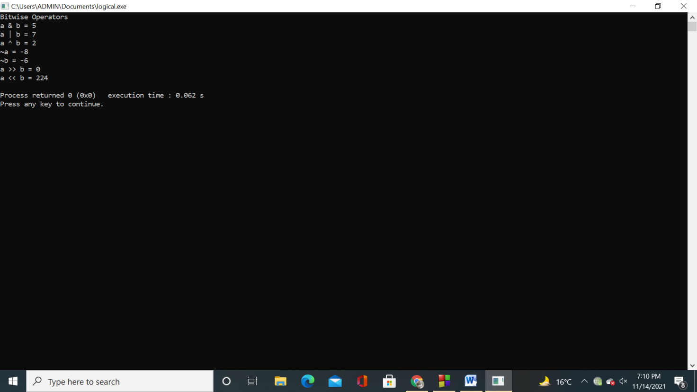

**F.program to use precedence and associativity of operators**

**Code:** **#include <iostream>**

**using namespace std;**

**int main() {**

**// evaluates 17 * 6 first**

**int num1 = 5 - 17 * 6;**

**// equivalent expression to num1**

**int num2 = 5 - (17 * 6);**

**// forcing compiler to evaluate 5 - 17 first**

**int num3 = (5 - 17) * 6;**

**cout << "num1 = " << num1 << endl;**

**cout << "num2 = " << num2 << endl;**

**cout << "num3 = " << num3 << endl;**

**return 0;**

**}**

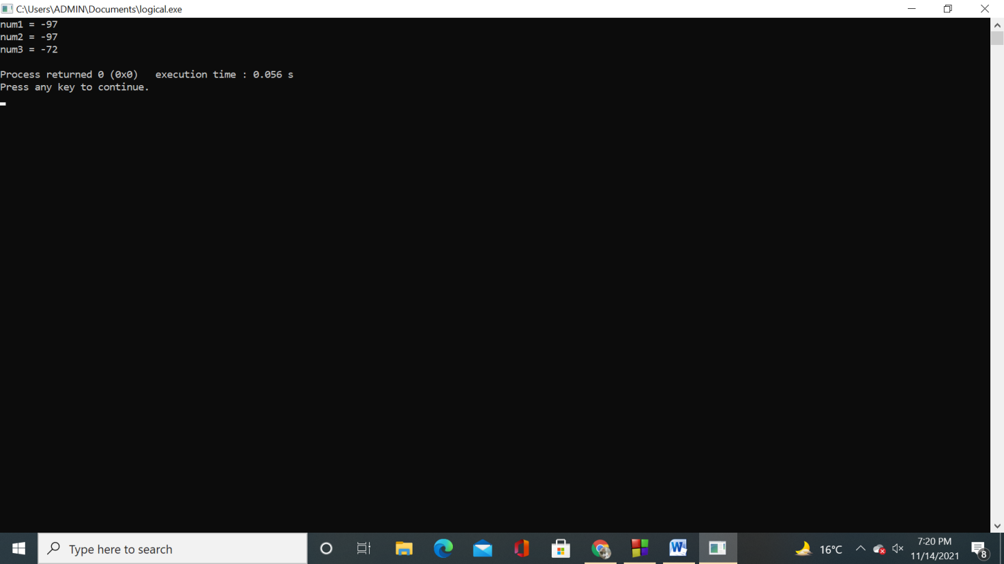

**Practical -5**

**Aim- write a program to find the greatest numbers among two using if –else statement**

**Code-**

#include<iostream>

using namespace std;

int main()

{

int x, y;

cout << "Please enter the Two Different Number = ";

cin >> x >> y;

if(x > y)

{

cout << x << " is Greater Than " << y;

}

else if(y > x)

{

cout << y << " is Greater Than " << x;

}

else

{

cout << "Both are Equal";

}

return 0;

}

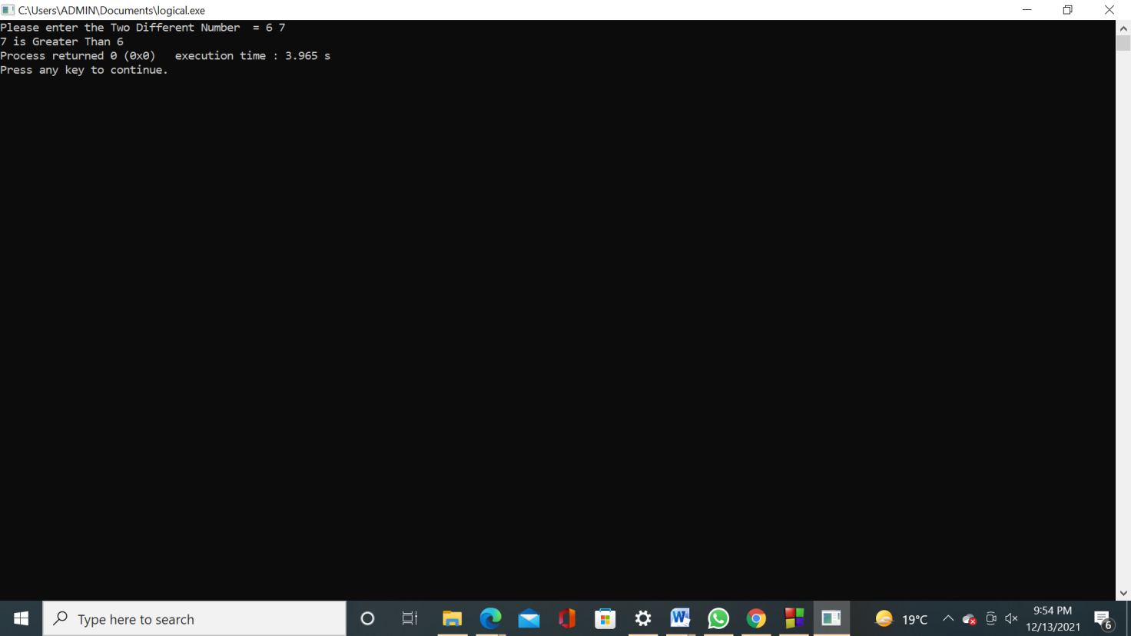

**Practical - 5**

**Aim- Program to illustrate if else statement.**

**Code:**

**#include <iostream>**

**using namespace std;**

**int main(){**

**int num=66;**

**if( num < 50 ){**

**//This would run if above condition is true**

**cout<<"num is less than 50";**

**}**

**else {**

**//This would run if above condition is false**

**cout<<"num is greater than or equal 50";**

**}**

**return 0;**

**}**

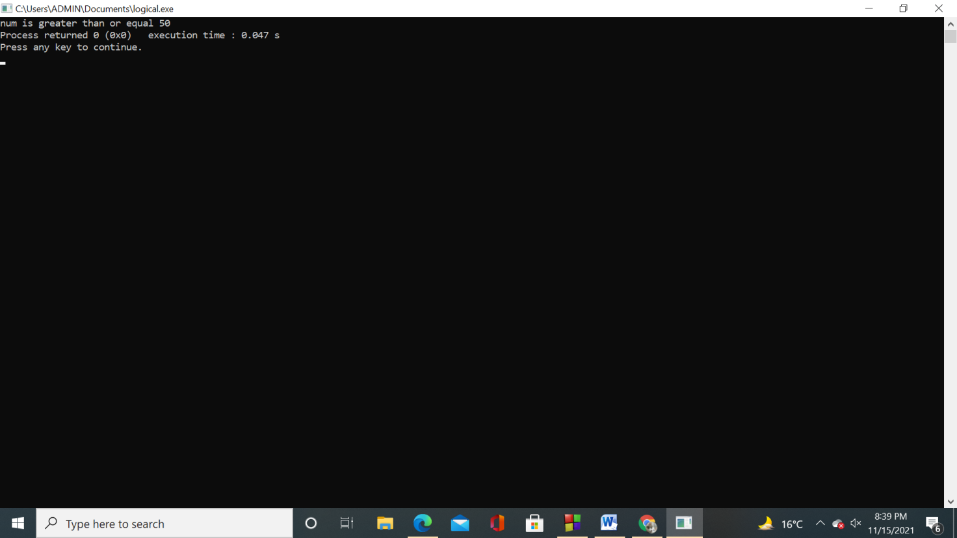

**Practical -6**

**Aim –write a program to check whether a number is +ve or –ve using if else ladder**

**Code-**

#include <iostream>

using namespace std;

int main()

{

signed long num1 = 0;

cout << "\n\n Check whether a number is positive, negative or zero :\n";

cout << "-----------------------------------------------------------\n";

cout << " Input a number : ";

cin >> num1;

if(num1 > 0)

{

cout << " The entered number is positive.\n\n";

}

else if(num1 < 0)

{

cout << " The entered number is negative.\n\n";

}

else

{

std::cout << " The number is zero.\n\n";

}

return 0;

}

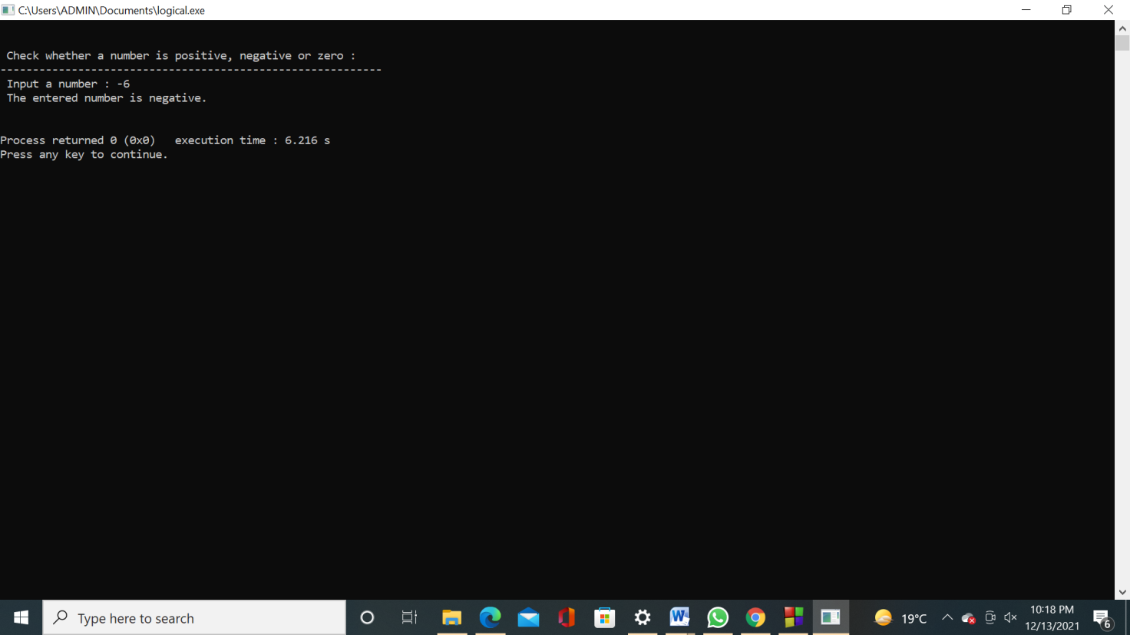

**Practical -6**

**Aim: program to illustrate the if- else ladder**

**Code:**

#include<iostream>

using namespace std;

int main()

{

int age;

cout<<"enter your age "<<endl;

cin>>age;

if((age<18)&&(age>=0))

{

cout<<"you can not come to party";

}

else if(age==18)

{

cout<<"you are kid and u will get a kid pass";

}

else if(age<0)

{

cout<<"you are not yet born";

}

else

{

cout<<"you can come to the party";

}

return 0;

}

**Practical – 7**

**Aim: Program to illustrate the nested if statement.**

**Code:** **#include <iostream>**

**using namespace std;**

**int main () {**

**int a = 100;**

**int b = 200;**

**if( a == 100 ) {**

**if( b == 200 ) {**

**cout << "Value of a is 100 and b is 200" << endl;**

**}**

**}**

**cout << "Exact value of a is : " << a << endl;**

**cout << "Exact value of b is : " << b << endl;**

**return 0;**

**}**

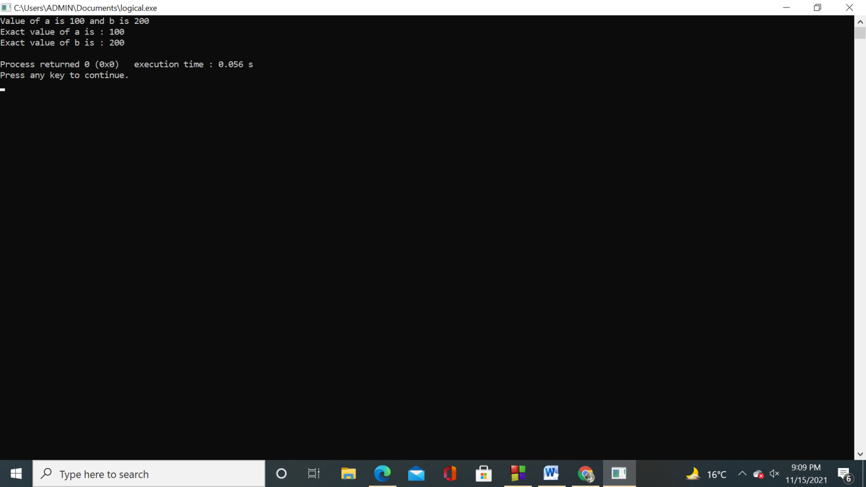

**Practical-8**

**Aim-program to illustrate switch statement**

**Code:**

**#include <iostream>**

**using** **namespace** std;

**int** main()

{

**int** weeknumber;

cout<<"Enter week number(1-7): ";

cin>>weeknumber;

**switch**(weeknumber)

{

**case** 1: cout<<"Monday";

**break**;

**case** 2: cout<<"Tuesday";

**break**;

**case** 3: cout<<"Wednesday";

**break**;

**case** 4: cout<<"Thursday";

**break**;

**case** 5: cout<<"Friday";

**break**;

**case** 6: cout<<"Saturday";

**break**;

**case** 7: cout<<"Sunday";

**break**;

**default**: cout<<"Invalid input! Please enter week no. between 1-7.";

}

**return** 0;

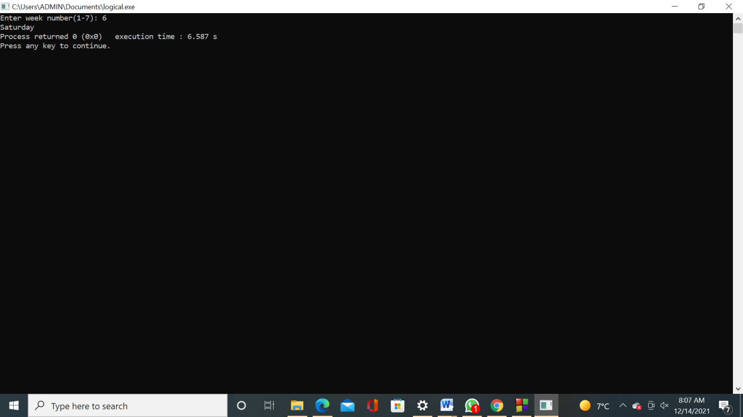

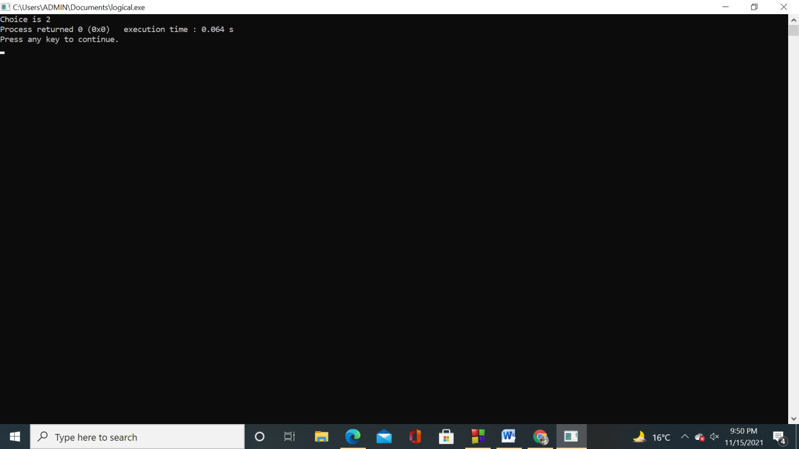

**Practical – 9**

**Aim:program to print the values using for loops**

**Code:**

#include<iostream>

Using namespace std;

Int main()

{int x=16;

int i,j;

cout<<Name –Harmanpreet kaur \nSection –ITA2\n Class roll no -2021042\n URN – 2004921\n’’;

for(i=1,j=4;i<4;i=i*2,j=j-2)

{

cout<<"\nhello"; cout<<"\nhi";

x=x+1; cout<<"\nx="<<x; cout<<"\ni="<<i; cout<<"\nj="<<j;

}

cout<<"\nbye";

}